1. Class Diagram :

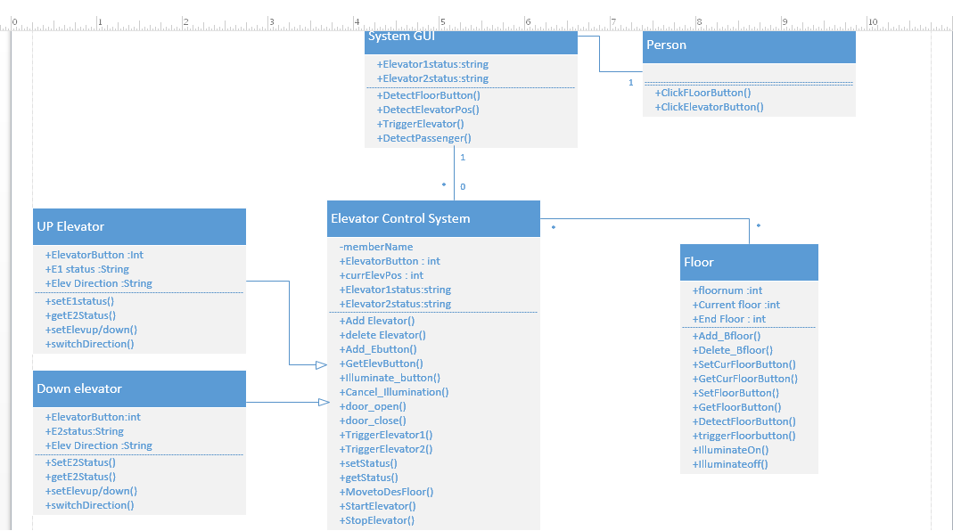

* Above is a class diagrammatic representation of an Elevator control system. In order to design the software 4 classes besides 2 sub classes for the elevator control system.
* “User /Passenger” move to the elevator system on the corresponding floor and click either of the buttons that is upward/downward.
* “System GUI” allows him to click the button before entering the elevator. It detects the user’s floor and triggers elevator to the corresponding floor.
* Elevator System Control is designed to be the central part of the system and looks after every action that an elevator has to perform. Attributes include the floor number, floor number as pressed by the passenger after entering the elevator, current floor status of the two elevators. Major functions include opening and closing doors, moving to the destined floor as given by the passenger, getting the status of the elevators, Illuminating buttons and canceling the illumination after floor is reached, also looks after the buttons located in the cabin of the elevator.
* Two sub classes “Up” and “Down” Elevators inherit the attributes like elevator current floor number, elevator’s status. As well inherits the functions like opening and closing the doors, Illuminating and cancelling the Illumination of the buttons, adding buttons.
* “Floor Class” is designed such that it is capable of looking after the floor level functions. It has attributes like floor number, User’s floor, elevator’s floor. Handles functions like adding floor buttons, checking the current floor of the elevator while it passes through the floors so as to check the intended floor level. First and last floors will have a single floor button where as rest are designed to have 2 buttons so as to direct the upward/downward direction for the ease of the passenger.
* Eventually system detects the exit of the user and makes elevator stay at that floor until it receives the next signal.

2. Sequence Diagram

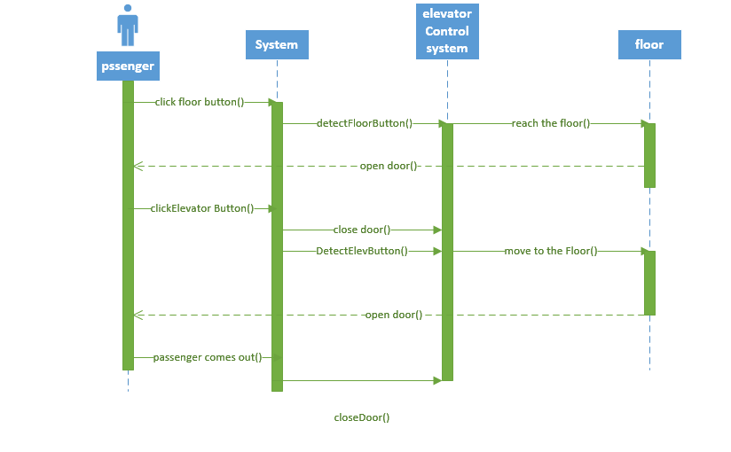

The sequence shows the necessary sequence of steps that are followed for a successful elevator’s software system pertaining to the floor button.

User who intends to catch up an elevator to make a move from ‘x’ floor to ‘y’ floor will reach the elevator step in point. User clicks the “floor Button” in the direction of the floor y. The elevator control system detects the floor button and triggers the elevator to move to the direction of the user’s floor.

Now the elevator opens door for passenger to get in to the elevator and allows him to click the necessary floor button from the cabin. Thusly clicked floor button is detected and user is taken to the floor and allows passenger to leave the elevator.

The final signal of the system detects the user vacating the elevator and the doors are closed. There after it remains steadily for the next user’s call.

3. Architecture Diagram of the Elevator system

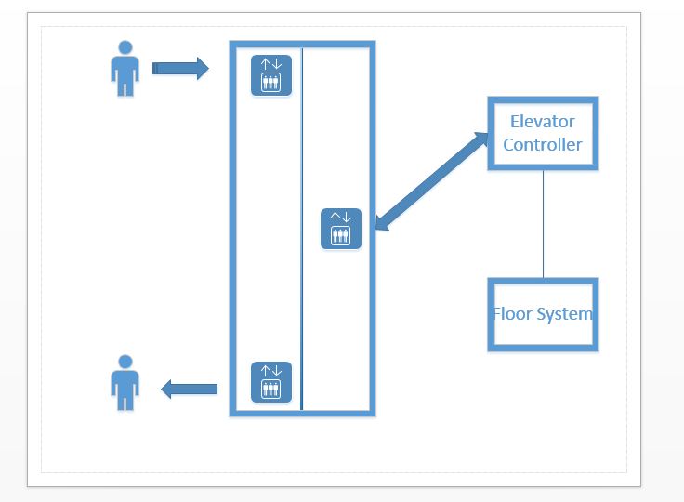

Above picture depicts the architectural view of the designed software product. After installing properly in the elevator system it allows User to enter and exit the elevator between the floors. He can call the elevator at any floor and click the destined floor. The whole control unit is served by the elevator controller and floor system together. It takes the necessary controlling measures for the elevator system to work properly. Can also handle the both elevators simultaneously following the intended system prerequisites.